**App name**:

VECINAPP

**Members**:

Francisco Garrido D’Agata

David Barraud

Rodrigo Grigera

Mauro Roberto Frutos

Gonzalo Gianelli

**In this brief review we want to introduce you to VECINAPP**

VECINAPP is an application designed especially for people over 18 years of age in our town.

Through this app, citizens will have the opportunity to express their complaints or concerns regarding things related to the city, such as: waste collection, ABL, state of the streets, etc. The neighbor will also be able to access information provided by the municipality such as: tourism, garbage recycling, cultural events, new provisions decreed by the mayor, among others.

The advantages that VECINAPP has are:

* The practicality when using it, also designed for those people who do not have much contact with the technological world.

*It is very agile and dynamic, which makes it very entertaining when browsing all its items.

In conclusion, our APP VECINAPP aims to strengthen the bond between the municipality and the citizens by promoting the participation of everyone.

**App's functionality**:  
Collect claims and suggestions from the people of our city(ABL, Residues, Claims).  
Bring forth information related to the municipality, such as: Turism, Recycling, Culture, and others.

**Composition:**

* Front-End, with a responsive, dynamic interface, interactive and user-friendly, with a clear menu and defined paths to content.
* Back-End, using primarily JavaScript, Typescript, Node.js.
* Databases, Using MongoDB or MySQL.

**Flow Diagram**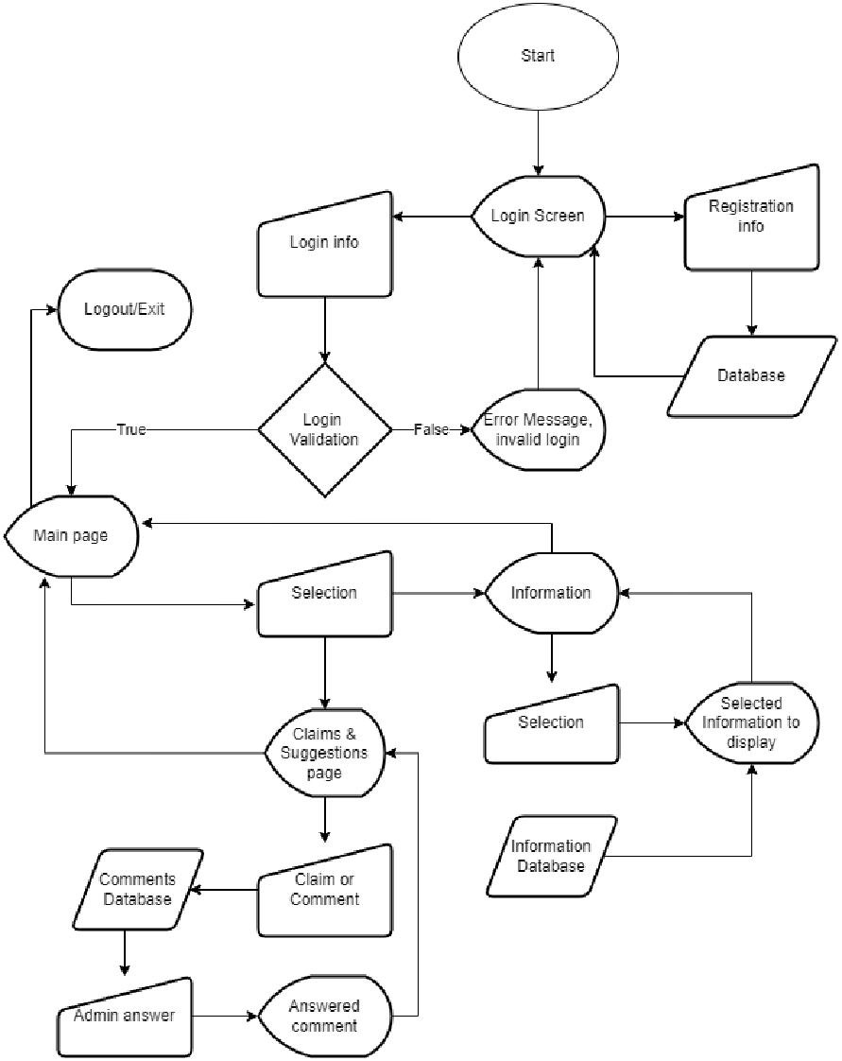

**Target User**: Citizens older than 18 years old from Balcarce.

**User type**:

1) Public User, logging into the app to make claims, suggestions or to browse the information provided.

2)Administrative user, taking charge of the claims and suggestions coming into the database.

**Pseudocode**

**Starting Screen or login screen**

* The user is presented with a space to fill his login info, a login button and a register button.
* The registration info is saved in a database to be used when logging in.

**Main Page:**

* The user will be able to choose from two sections, “Claims and Suggestions” & “Categories”

**Claims page:**

* The user will be able to generate a comment, which will be saved in a database to be answered or reviewed by an administrator.
* The answer is portrayed directly in the app, following the comment, and the commenting user will get a notification from the app.

**Categories Page:**

* The information provided by the municipality will be on display on this screen, from which the user will be able to select one to browse

**Information Page:**

* Displays on screen the information related to the category selected on the Categories Page.

**Logout Button:**

* A button to log out from the app/web

**PRODUCT BACKLOG:**

**----**

**Starting Screen or login screen**

* The user is presented with a space to fill his login info, a login button and a register button.
* The registration info is saved in a database to be used when logging in.

**----**

**Main Page:**

* The user will be able to choose from two sections, “Claims and Suggestions” & “Categories”

**----**

**Claims page:**

* The user will be able to generate a comment, which will be saved in a database to be answered or reviewed by an administrator.
* The answer is portrayed directly in the app, following the comment, and the commenting user will get a notification from the app.

**----**

**Categories Page:**

* The information provided by the municipality will be on display on this screen, from which the user will be able to select one to browse

**----**

**Information Page:**

* Displays on screen the information related to the category selected on the Categories Page.

**----**

**Logout Button:**

* A button to log out from the app/web

---------

**SPRINT 1:**

Deliver of Main page, with a basic functionality

--

Francisco : Page design.

David : Claims & Suggestions button and its functionality.

Rodrigo :Categories button and its functionality.

Mauro : HTML

Gonzalo : CSS

STARTED 12/11

DELIVERED 25/11